SUPPLEMENTARY MATERIALS
Supplemental Fig. 1: Minimum distance traveled from soft release pens by Rehab M2 and Rehab F.
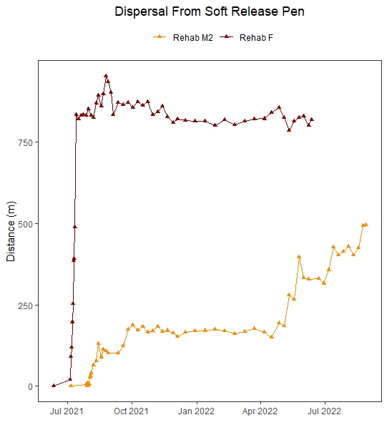

Supplemental Fig. 2: Body Condition Index (BCI) scores of study participants (Rehab M1 not shown) over the course of the study period. In these four plots, lines of best fit and associated R² values describe potential linear trends in BCI across the study period.