Supplementary Material
The hack boxes were designed to allow for continuous monitoring of the birds, as well as release and feeding with minimal disturbance. The below images illustrate some of these details.

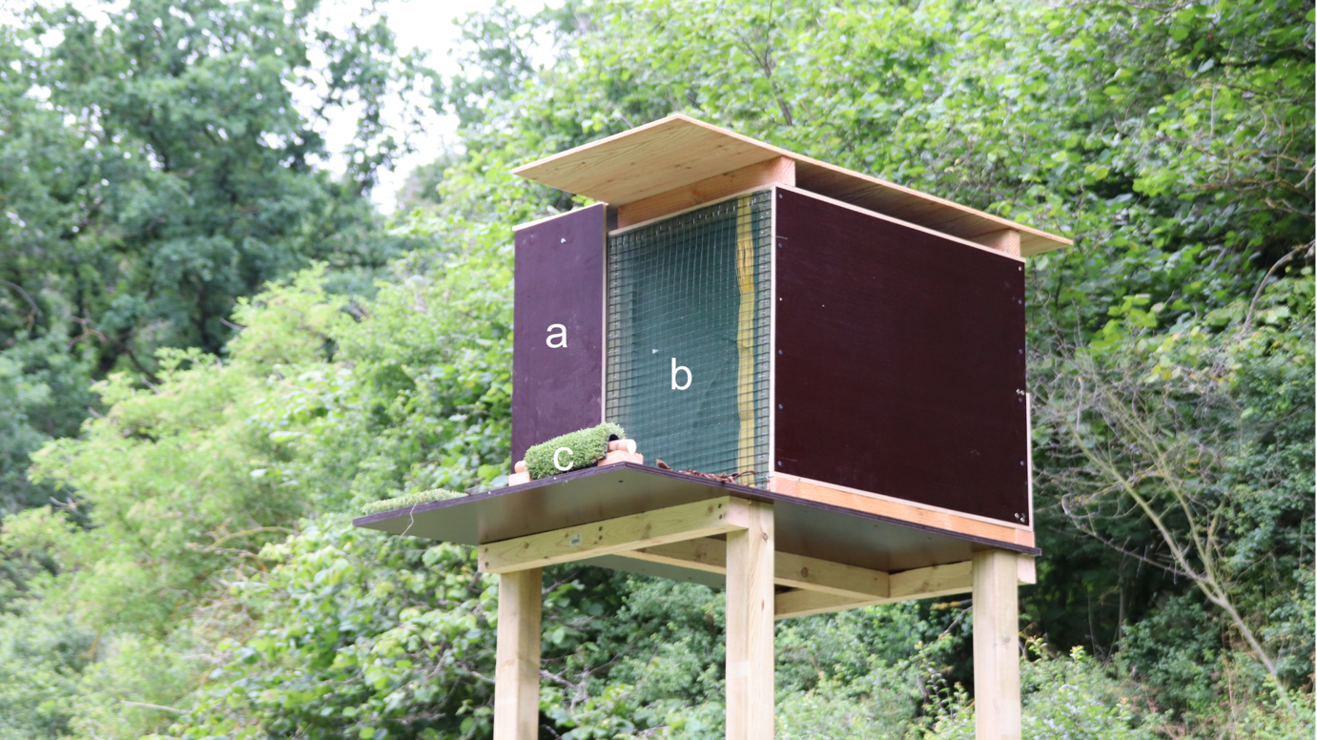
Supplementary Figure 1: Front view of hack box, featuring release hatch (a), which can be lowered using a string pulley system, secure viewing window (b), from which the birds can view their surroundings and landing/feeding platform (c), which was used for feeding after release. Note: installation of a layer of silo netting on the inside of the window wire, to prevent feather damage as well as to protect the birds from fly or wasp disturbance.

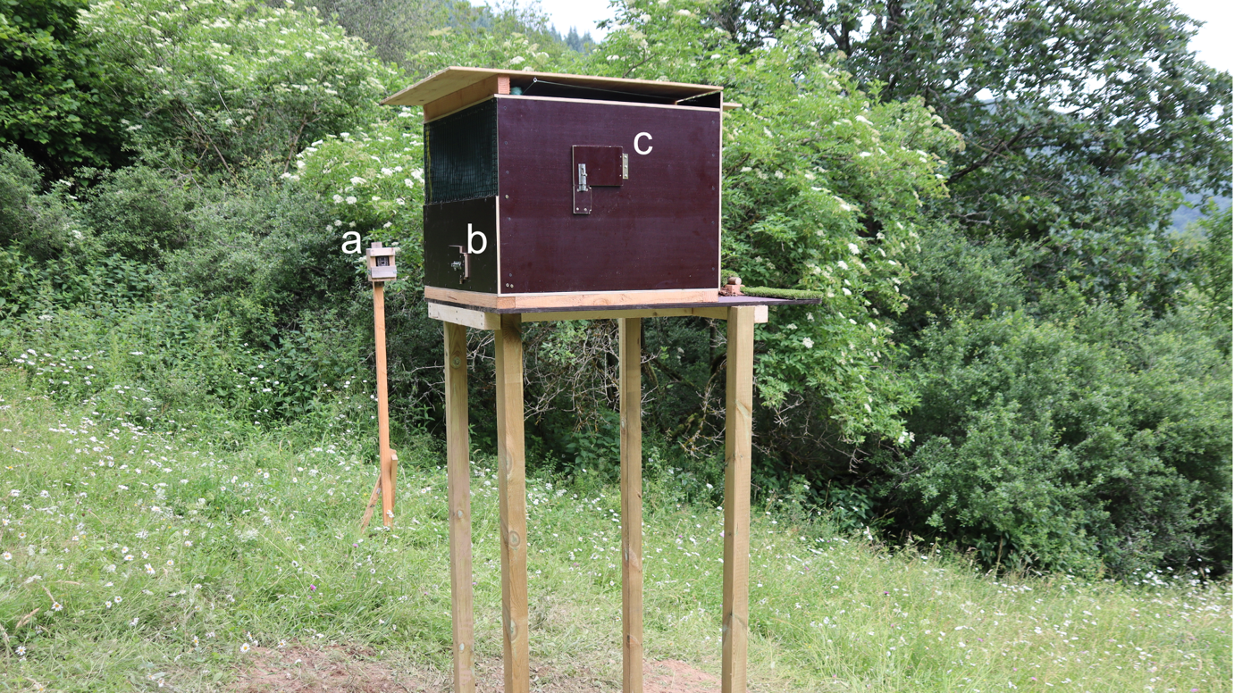
Supplementary Figure 2: Rear and side view of hack box, with trail camera mount (a), hack box camera hatch (b) and feeding hatch (c). Note: installation of a layer of silo netting on the inside of the rear window wire, to prevent feather damage as well as to protect the birds from fly or wasp disturbance

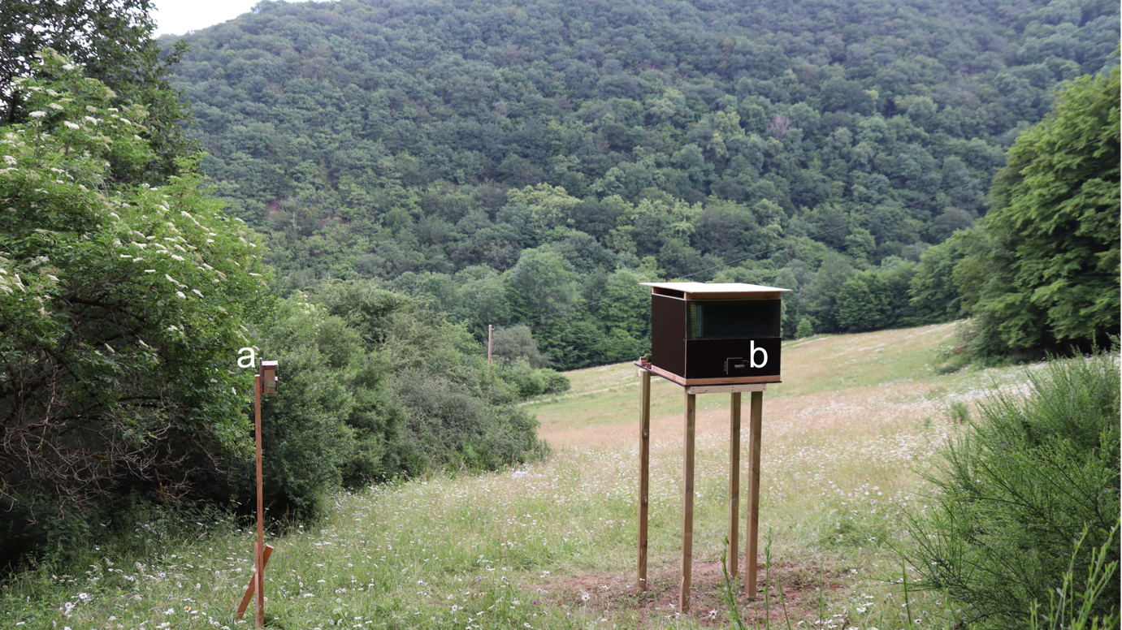
Supplementary Figure 3: Hack box in situ, with view of the release site, trail camera mount (a) and hack box camera hatch (b).

The links below show some example video footage of the birds from the external trail camera as well as the internal hack box camera.

Video 1: Internal camera on day 2 after entering the box, used to monitor the kestrels in the hack box prior to release.
https://drive.google.com/file/d/1OS77_5Rkrc1fJcn4DL_KgogcMB2arbGN/view?usp=sharing

Video 2: First moments after the kestrels were released from the hack box, stretching their wings.
https://drive.google.com/file/d/1_itNEDSUSLTpjDm7cL_3GeuM7csSWM9M/view?usp=sharing

Video 3: Kestrel taking refuge from the rain on day 2 after release.
https://drive.google.com/file/d/1tpvL3FRypiWecIw16v7mcFX0k8Zc6k0n/view?usp=sharing

Video 4: Two kestrels feeding at the hack box on day 4 after release.
https://drive.google.com/file/d/1lOh7aU_foihW6RhiSuXnD5xlZ_6WTRi_/view?usp=sharing

Video 5: Kestrel taking flight from the hack box with food on day 4 after release.
https://drive.google.com/file/d/1mrVF9UcPijVd8mI-1ZWmdAN01bwMXt6y/view?usp=sharing

